**Test a Perceptual Phenomenon**

**1. What is our independent variable? What is our dependent variable?**

The word condition is the independent variable i.e. conditions: a congruent words condition, and an incongruent words condition

The time it takes to name the ink colors in the list is the dependent variable.

2**. What is an appropriate set of hypotheses for this task? What kind of statistical test do you expect to perform? Justify your choices.**

My hypothesis will be time difference between non-congruent and the congruent phase Is more than half of the congruent phase time, i.e. in the μ(incongruent) – μ(congruent) > 0.5*μ(congruent)

Null hypothesis will be: μ(incongruent) – μ(congruent) <= 0.5*μ(congruent)

Alternative hypothesis will be: μ(incongruent) – μ(congruent) > 0.5*μ(congruent)

For the above hypothesis, I will be using dependent samples t-test because of following reasons,

* Both of the two samples (for congruent and incongruent word condition) are same, so dependent samples will be appropriate for this,
* Don’t have access to the population parameters, so t-test will be appropriate for that.

**3. Report some descriptive statistics regarding this dataset. Include at least one measure of central tendency and at least one measure of variability.**

For the data provided for the tests, following are the means and standard deviations for each word condition,

|  |  |  |
| --- | --- | --- |
|  | **Congruent** | **Incongruent** |
| **Mean** | 14.05 | 22.02 |
| **Standard deviation** | 3.48 | 4.69 |

**4. Provide one or two visualizations that show the distribution of the sample data. Write one or two sentences noting what you observe about the plot or plots.**

Below is the box plot for each of the word conditions,

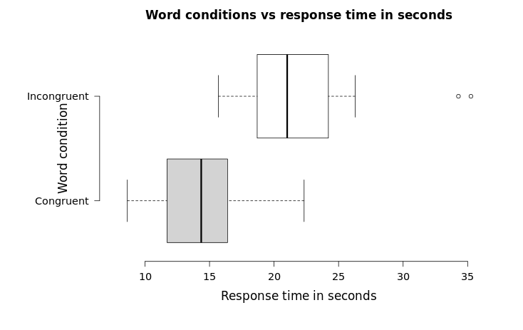

And below graph shows distribution of response times in sequence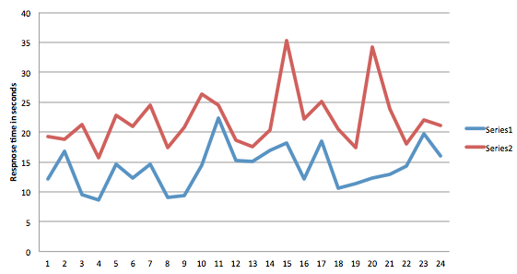

Although it looks that the response time for the incongruent phase will be significantly different form the congruent phase, but it will further be confirmed in the next dependent samples t-test.

**5. Now, perform the statistical test and report your results. What is your confidence level and your critical statistic value? Do you reject the null hypothesis or fail to reject it? Come to a conclusion in terms of the experiment task. Did the results match up with your expectations?**

The alpha value for the t-test will be 0.05 and the test will be one tail with positive direction. Corresponding t-critical value will be 1.684. And preforming the t-test for the above data will yields following results,

|  |  |  |  |
| --- | --- | --- | --- |
| **Congruent** | **Incongruent** | **Difference** | **SSE** |
| 12.079 | 19.278 | 1.1595 | 0.04851924 |
| 16.791 | 18.741 | -6.4455 | 54.53422487 |
| 9.564 | 21.214 | 6.868 | 35.15032359 |
| 8.63 | 15.687 | 2.742 | 3.249982678 |
| 14.669 | 22.803 | 0.7995 | 0.01952424 |
| 12.238 | 20.878 | 2.521 | 2.501998969 |
| 14.692 | 24.572 | 2.534 | 2.543294011 |
| 8.987 | 17.394 | 3.9135 | 8.84628699 |
| 9.401 | 20.762 | 6.6605 | 32.73293995 |
| 14.48 | 26.282 | 4.562 | 13.12446851 |
| 22.328 | 24.524 | -8.968 | 98.15318976 |
| 15.298 | 18.644 | -4.303 | 27.48096664 |
| 15.073 | 17.51 | -5.0995 | 36.46624995 |
| 16.929 | 20.33 | -5.0635 | 36.03275745 |
| 18.2 | 35.255 | 7.955 | 49.22104039 |
| 12.13 | 22.158 | 3.963 | 9.143190053 |
| 18.495 | 25.139 | -2.6035 | 12.55092995 |
| 10.639 | 20.429 | 4.4705 | 12.4698737 |
| 11.344 | 17.425 | 0.409 | 0.281142969 |
| 12.369 | 34.288 | 15.7345 | 218.900039 |
| 12.944 | 23.894 | 4.478 | 12.52289901 |
| 14.233 | 17.96 | -3.3895 | 18.7378962 |
| 19.71 | 22.058 | -7.507 | 71.33878714 |
| 16.004 | 21.157 | -2.849 | 14.35068022 |

**Calculated SD of population: 5.79**

**μ(incongruent) – 1.5*μ(congruent): 0.94**

**t-score : 0.79**

Based on the result for the above test compared to the t-critical value for the test, it failed to reject the null hypothesis.

For better approximation, it will be better to have different samples for each of the test, as it will eradicate carryover effect and the more samples we have, the more will be accurate for out results. Well, it does not match to my expectation, I expected that the difference in the means response times for incongruent and congruent scores will roughly more than half of the congruent score, but the t-test failed to reject the null hypothesis and difference comes up to be lesser than half of the congruent response time.